**TUTORIAL 2**

AIM:

create the webpage given below

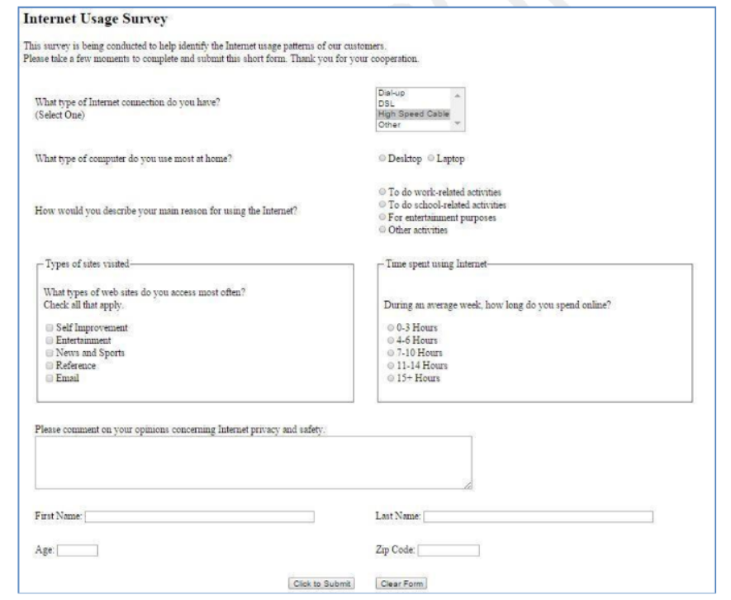

Program:

<!DOCTYPE html>

<html lang="en">

<head>

<meta charset="UTF-8" />

<meta http-equiv="X-UA-Compatible" content="IE=edge" />

<meta name="viewport" content="width=device-width, initial-scale=1.0" />

<title>Document</title>

<style>

.main {

border: solid 2px;

border-color: blue;

padding: 5px 5px;

}

.sec {

padding-left: 15px;

}

.menu {

position: relative;

left: 30%;

bottom: 20px;

}

.radio1 {

float: right;

position: relative;

bottom: 20px;

right: 56%;

}

.radio2 {

float: right;

position: relative;

bottom: 30px;

right: 52%;

}

.sec-2 {

padding-left: 15px;

border: solid 2px;

width: 500px;

}

.sec2-inner {

position: relative;

bottom: 12px;

}

.sec-2Para {

position: relative;

bottom: 25px;

background-color: whitesmoke;

width: 140px;

}

.sec-3 {

padding-left: 15px;

border: solid 2px;

width: 515px;

position: relative;

left: 550px;

bottom: 210px;

padding-bottom: 18px;

}

.sec-3Para {

position: relative;

bottom: 25px;

background-color: whitesmoke;

width: 180px;

}

.sec-4 {

position: relative;

bottom: 60px;

}

.lastname {

position: relative;

left: 140px;

}

.zipcode {

position: relative;

left: 524px;

}

.buttons {

position: relative;

left: 500px;

top: 50px;

margin: 10px;

padding: 3px;

}

</style>

</head>

<body>

<section class="main">

<h1>Internet Usage Survey</h1>

<br />

<p>

This survey is being conducted to help identify the Internet usage

patterns of our customers.

<br />

Please take a few moment to complete and submit this short form. Thank

you for your cooperation

</p>

<br />

<br />

<div class="sec">

<form action="">

<label for="internet"

>What type of Internet connection do you have? <br />(Select

One)</label

>

<select class="menu" name="internet" id="internet">

<option value="dial-up">Dial-up</option>

<option value="dsl">DSL</option>

<option value="highSpeedCable">High Speed Cable</option>

<option value="other">Other</option>

</select>

<br />

<br />

<br />

<br />

<label for="computer"

>What type of computer do you use most at home?</label

>

<br />

<div class="radio1">

<input type="radio" name="computer" id="desktop" />

<label for="desktop">Desktop</label>

<input type="radio" name="computer" id="laptop" />

<label for="laptop">Laptop</label>

</div>

<br />

<br />

<br />

<br />

<br />

<label for="reason"

>How would you describe your main reason for using Internet?</label>

<div class="radio2">

<input type="radio" name="reason" id="work" />

<label for="desktop">To do work related activities</label>

<br />

<input type="radio" name="reason" id="school" />

<label for="laptop">To do School related activities</label>

<br />

<input type="radio" name="reason" id="entertainment" />

<label for="laptop">For entertainment purposes</label>

<br />

<input type="radio" name="reason" id="other" />

<label for="laptop">Other activities</label>

</div>

<br />

<br />

<br />

<br />

<br />

<div class="sec-2">

<p class="sec-2Para">Types of sites visited</p>

<div class="sec2-inner">

<p>

What type of web do you access most often? <br />Check all that

apply

</p>

<input type="checkbox" />

<label for="selfImprovement">Self Imporvement</label>

<br />

<input type="checkbox" />

<label for="entertainment">Entertainment</label>

<br />

<input type="checkbox" />

<label for="newsSports">News and Sports</label>

<br />

<input type="checkbox" />

<label for="reference">Reference</label>

<br />

<input type="checkbox" />

<label for="email">Email</label>

</div>

</div>

<div class="sec-3">

<p class="sec-3Para">Time spent using Internet</p>

<p>During an average week. How long do you spend?</p>

<input type="radio" name="time" id="0-3" />

<label for="">0-3 Hours</label>

<br />

<input type="radio" name="time" id="4-6" />

<label for="">4-6 Hours</label>

<br />

<input type="radio" name="time" id="7-10" />

<label for="">7-10 Hours</label>

<br />

<input type="radio" name="time" id="11-14" />

<label for="">11-14 Hours</label>

<br />

<input type="radio" name="time" id="15" />

<label for="">15 Hours</label>

</div>

<div class="sec-4">

<p>

Please comment on your opinion concerning internet privacy and

safety:

</p>

<textarea name="address" id="" cols="100" rows="5"></textarea>

<br />

<br />

<br />

<label for="firstname">First Name</label>

<input type="text" style="width: 400px" />

<label class="lastname" for="lastname">Last Name</label>

<input class="lastname" type="text" style="width: 400px" />

<br />

<br />

<label for="age">Age</label>

<input type="text" style="width: 60px" />

<label class="zipcode" for="zipcode">Zip Code</label>

<input

class="zipcode"

type="text"

minlength="6"

maxlength="6"

style="width: 80px"

/>

<br />

<br />

<input class="buttons" type="submit" value="clik to submit" />

<input class="buttons" type="reset" value="clear form" />

</div>

</form>

</div>

</section>

</body>

</html>